IDEATION PHASE

EMPATHY MAP

|  |  |
| --- | --- |
| DATE | 10 September 2022 |
| TEAM ID | PNT2022TMID27630 |
| PROJECT NAME | Virtual Eye - LifeGuard For Swimming Pools  To Detect |
| MAXIMUM MARKS | 4 MARKS |

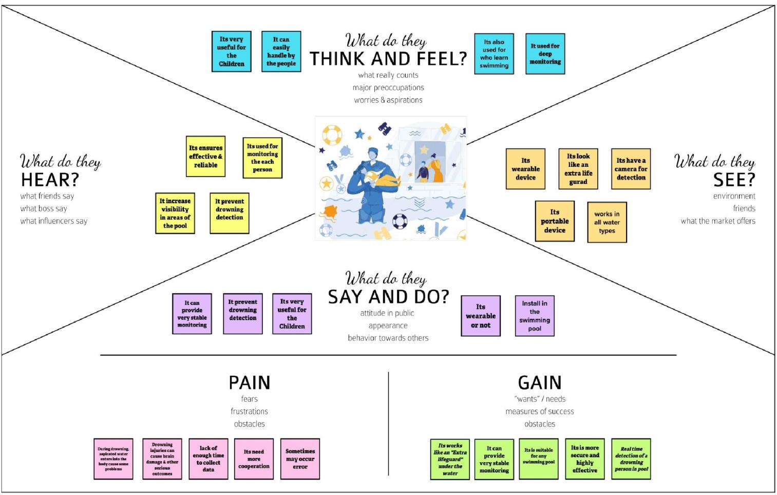EMPATHY MAP :

